**Project Planning Phase**

**Project Planning Template (Product Backlog, Sprint Planning, Stories, Story points)**

|  |  |
| --- | --- |
| Date | 25 October 2022 |
| Team ID | PNT2022TMID46479 |
| Project Name | CUSTOMER CARE REGISTRY |
| Maximum Marks | 8 Marks |

**Product Backlog, Sprint Schedule, and Estimation (4 Marks)**

|  |  |  |  |  |  |  |
| --- | --- | --- | --- | --- | --- | --- |
| **Sprint** | **Functional**  **Requirement (Epic)** | **User Story**  **Number** | **User Story / Task** | **Story Points** | **Priority** | **Team Members** |
| Sprint-1 | Customer Panel | USN-1 | As a Customer, I can register for the application by entering my email, password, and confirming my password and I will be able to Access my dashboard for creating a Query Order. | 2 | High | Jeeva M  Jaya Prakash A  Balamurugan R |
| Sprint-1 | Admin Panel | USN-2 | As an admin, I can Login to the Application by entering correct login credentials and I will be able to Access My dashboard to create Agents and Assign an Agent to a Query Order. | 2 | High | Arikrishnan S  Jaya Prakash A  Balamurugan R |
| Sprint-2 | Agent Panel | USN-3 | As an agent, I can Login to the Application by entering correct login credentials and I will be able to Access my Dashboard to check the  Query Order and I can Clarify the Issues. | 2 | High | Jeeva M  Jaya Prakash A  Balamurugan R |
| Sprint-3 | Chat Bot | USN-4 | The Customer can directly Interact to the Chatbot regarding the services offered by the Web Portal and get recommendations based on information provided by them. | 2 | Medium | Arikrishnan S  Jaya Prakash A  Balamurugan R |
| Sprint-4 | Final Delivery | USN-5 | Container of applications using docker kubernetes and deployment the  application.Create the documentation and final submit the application | 2 | High | venkatesh v naveen kumar s Mukilan k barani a |

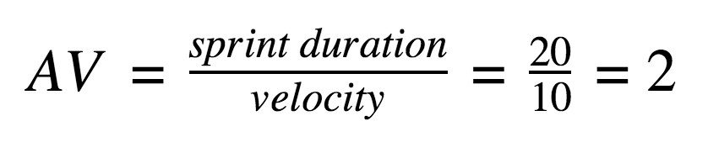**Project Tracker, Velocity & Burndown Chart: (4 Marks)**

|  |  |  |  |  |  |  |
| --- | --- | --- | --- | --- | --- | --- |
| **Sprint** | **Total Story Points** | **Duration** | **Sprint Start Date** | **Sprint End Date (Planned)** | **Story Points**  **Completed (as on**  **Planned End Date)** | **Sprint Release Date (Actual)** |
| Sprint-1 | 20 | 7 Days | 24 Oct 2022 | 30 Oct 2022 |  | 30 Oct 2022 |
| Sprint-2 | 20 | 7 Days | 31 Oct 2022 | 06 Nov 2022 |  | 06 Nov 2022 |
| Sprint-3 | 20 | 8 Days | 07 Nov 2022 | 14 Nov 2022 |  | 14 Nov 2022 |
| Sprint-4 | 20 | 7 Days | 14 Nov 2022 | 21 Nov 2022 |  | 21 Nov 2022 |

**Velocity:**

Imagine we have a 10-day sprint duration, and the velocity of the team is 20 (points per sprint). Let’s calculate the team’s average velocity (AV) per iteration unit (story points per day)

**Burndown Chart:**

A burndown chart is a graphical representation of work left to do versus time. It is often used in agile [software](https://www.visual-paradigm.com/scrum/what-is-agile-software-development/) [development](https://www.visual-paradigm.com/scrum/what-is-agile-software-development/) methodologies such as [Scrum](https://www.visual-paradigm.com/scrum/scrum-in-3-minutes/). However, burn down charts can be applied to any project containing measurable progress over time.

